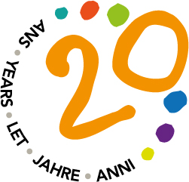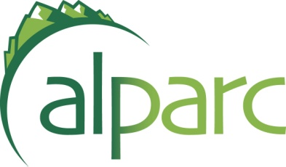

Workshop 20 years of ALPARC
“Alpine protected areas 2030 – A shared vision for the future”

the 13th of October 2015
Haus der Berge - Berchtesgaden National Park – Germany

REGISTRATION FORM
Anmeldeformular / Bulletin d’inscription / Scheda d’iscrizione

Page 2 TO SEND BACK TO:

info@alparc.org (or by Fax: +33 (0)479 26 55 01)

before the 25th of September 2015

Les places sont limitées pour permettre un réel travail de groupe durant la réunion.
Um ein effizienteres Arbeiten in der Gruppe zu gewährleisten ist die Teilnehmerzahl begrenzt.

I posti sono limitati per permettere un lavoro di gruppo efficace durante la riunione.

Read the practical information in Appendix

Les frais de voyage et d’hébergement sont à la charge du participant.
I costi del viaggio e l’alloggio sono a carico del partecipante.
Die Kosten für Anreise und Unterkunft sind vom Teilnehmer selbst zu tragen.

ACCOMODATION BOOKING

Merci de réserver directement votre hébergement auprès de l’office du tourisme, voir le document « Practical information » joint.
Vi preghiamo di prenotare la vostra sistemazione presso l’Ufficio del Turismo. Vedi il documento in allegato “Practical Information”.
Bitte reservieren Sie ihre Unterkunft direkt beim Tourismusbüro, siehe Anhang „Practical information“.
Registration - Workshop 2015
Registration form / Anmeldeformular / Bulletin d’inscription / Scheda d’iscrizione / Anmeldeformular / Bulletin d’inscription / Scheda d’iscrizione

Organisation / Protected Area
Title, NAME + First name | Mr / Mrs / Ms
Function / position (in charge of…):
Address:
Email:
Tel.:
ARRIVAL: date and time
DEPARTURE: date and time

My organisation is a member of ALPARC

MEALS AND DRINKS:
Alpine aperitif on 12 October
YES, I can bring regional product(s) to share at the Alpine aperitif on 12 October

Dinner on 12 October

Lunch on 13 October

Dinner on 13 October

EXCURSION:
YES, I’m interested in a guided excursion in the National Park on 14 October
(for non-council members)
COUNCIL MEETING
YES, I will be present at the ALPARC council meeting on 14 October
(for council members)

Date: Signature:

